Docker CICD Pipeline Project

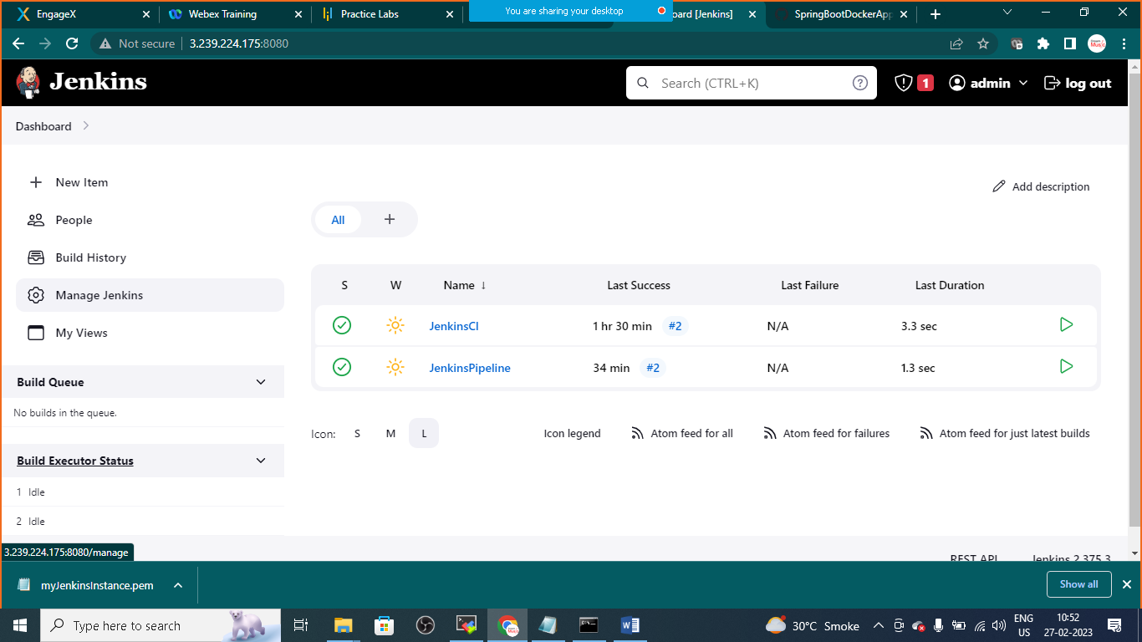

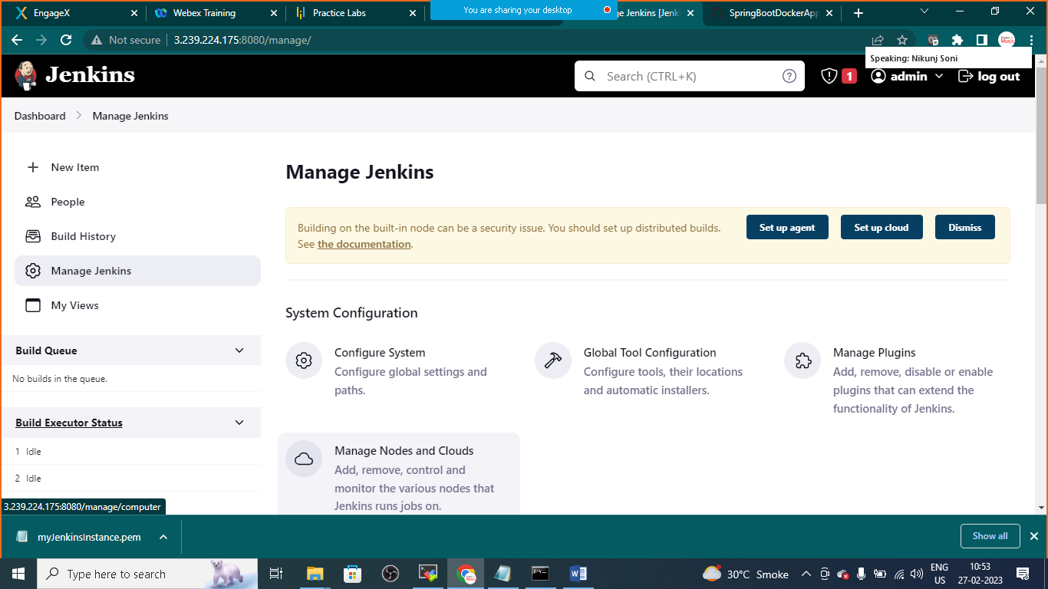

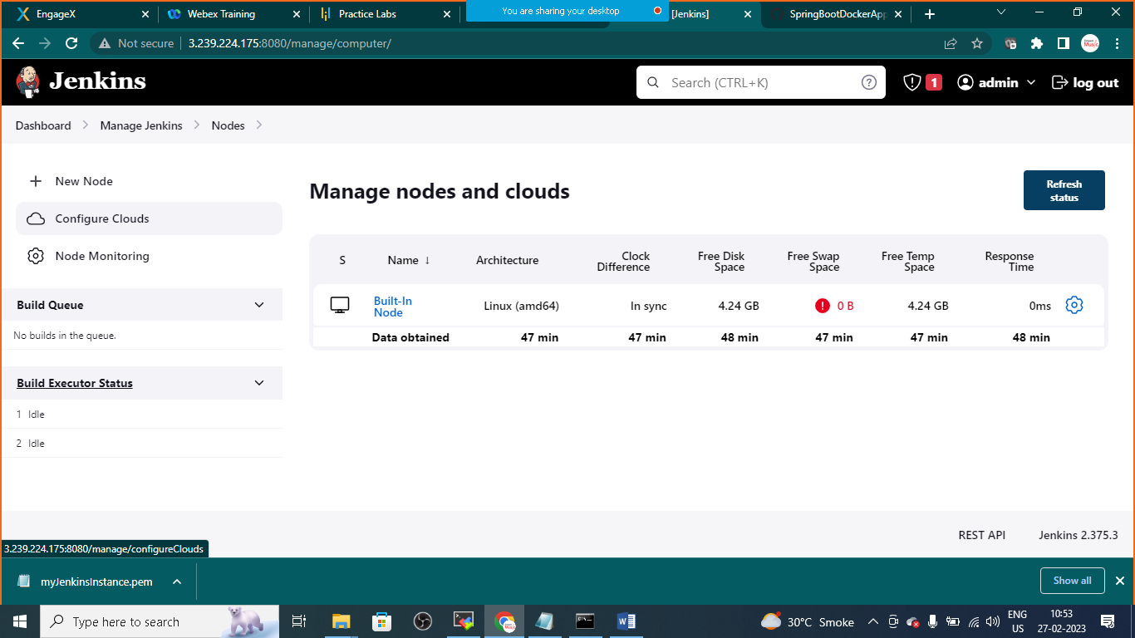

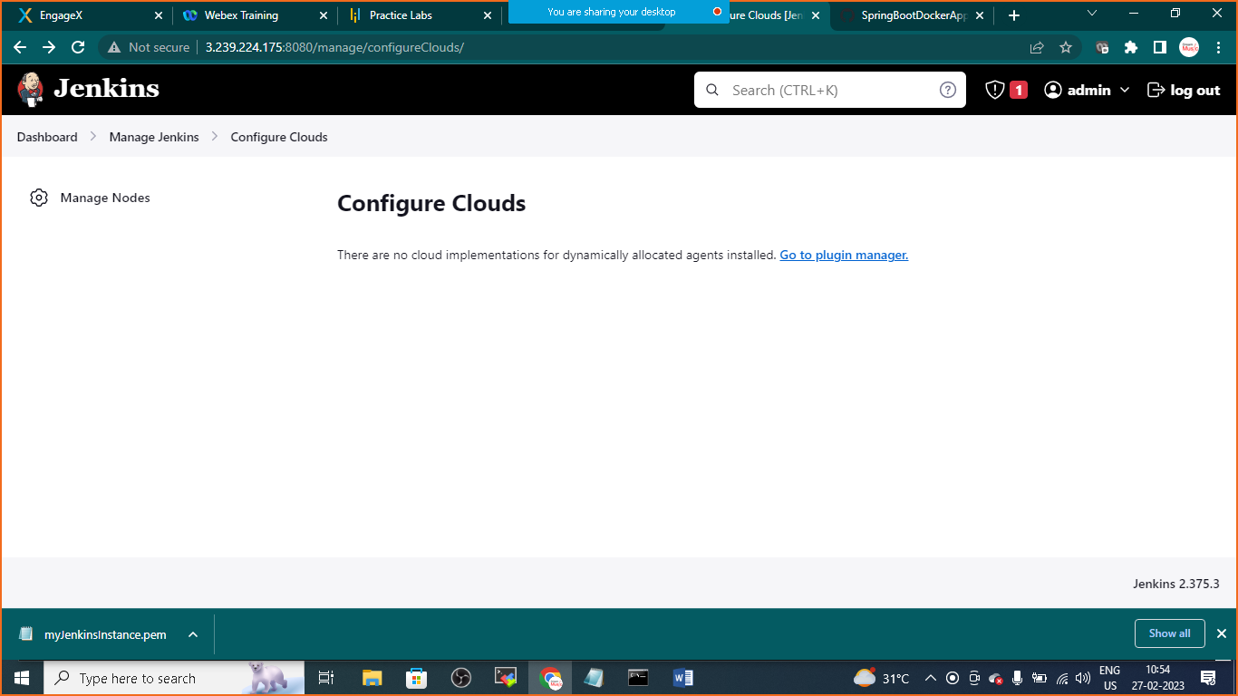

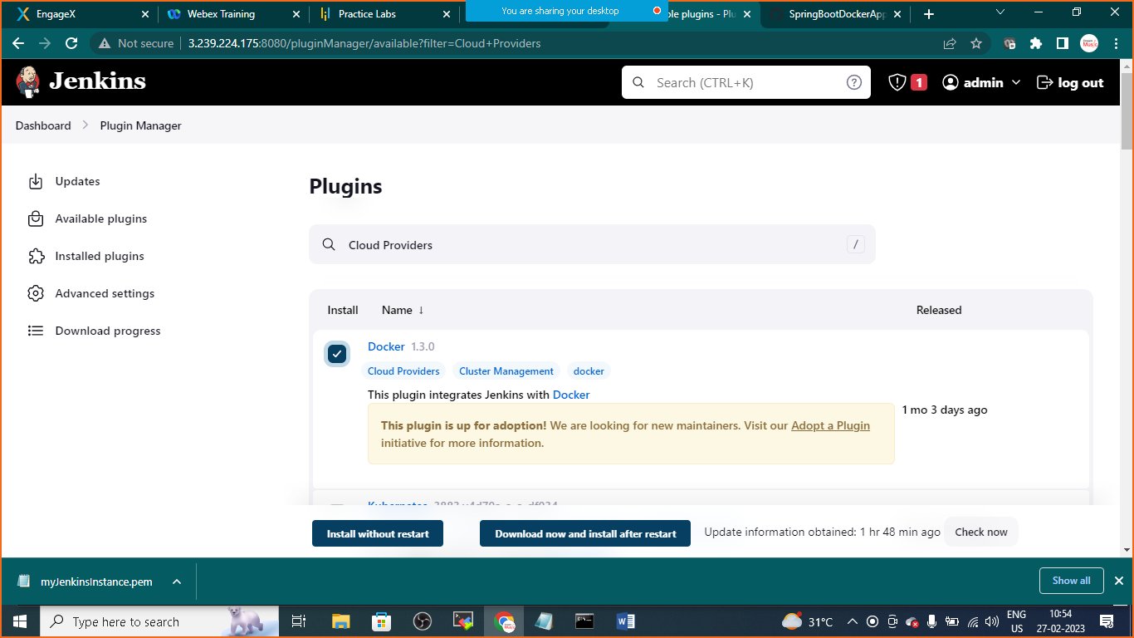

Goto>managejenkins>clouds>configure clouds>choose docker

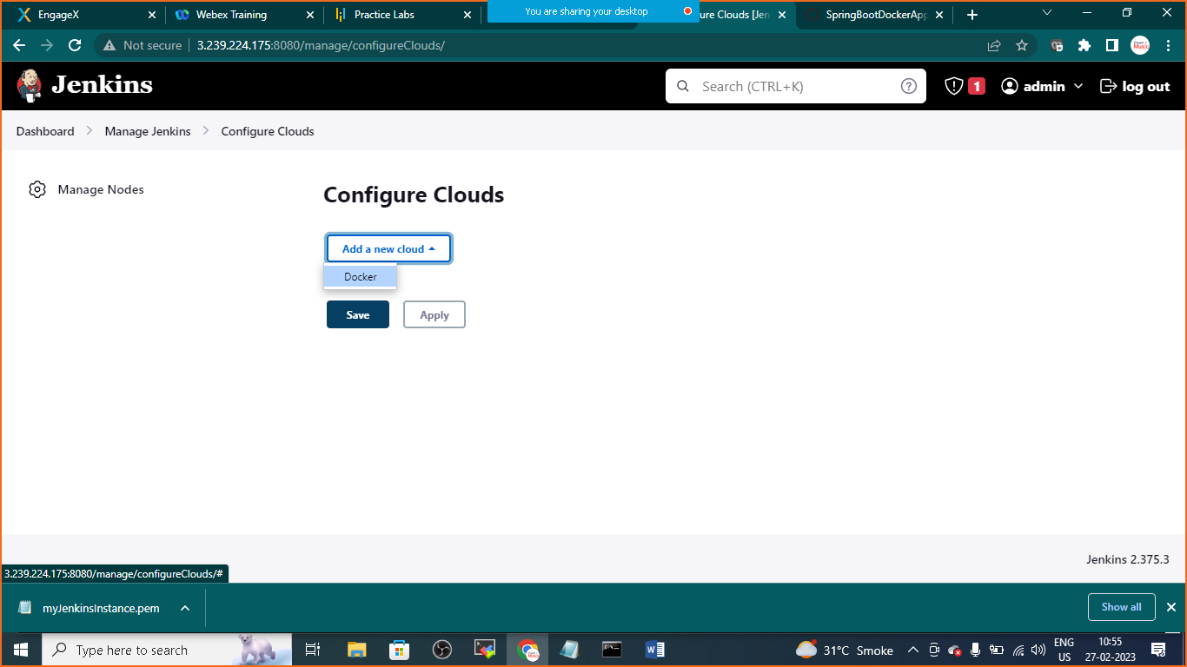

HOST URI: unix:///var/run/docker.sock

Click on test connections

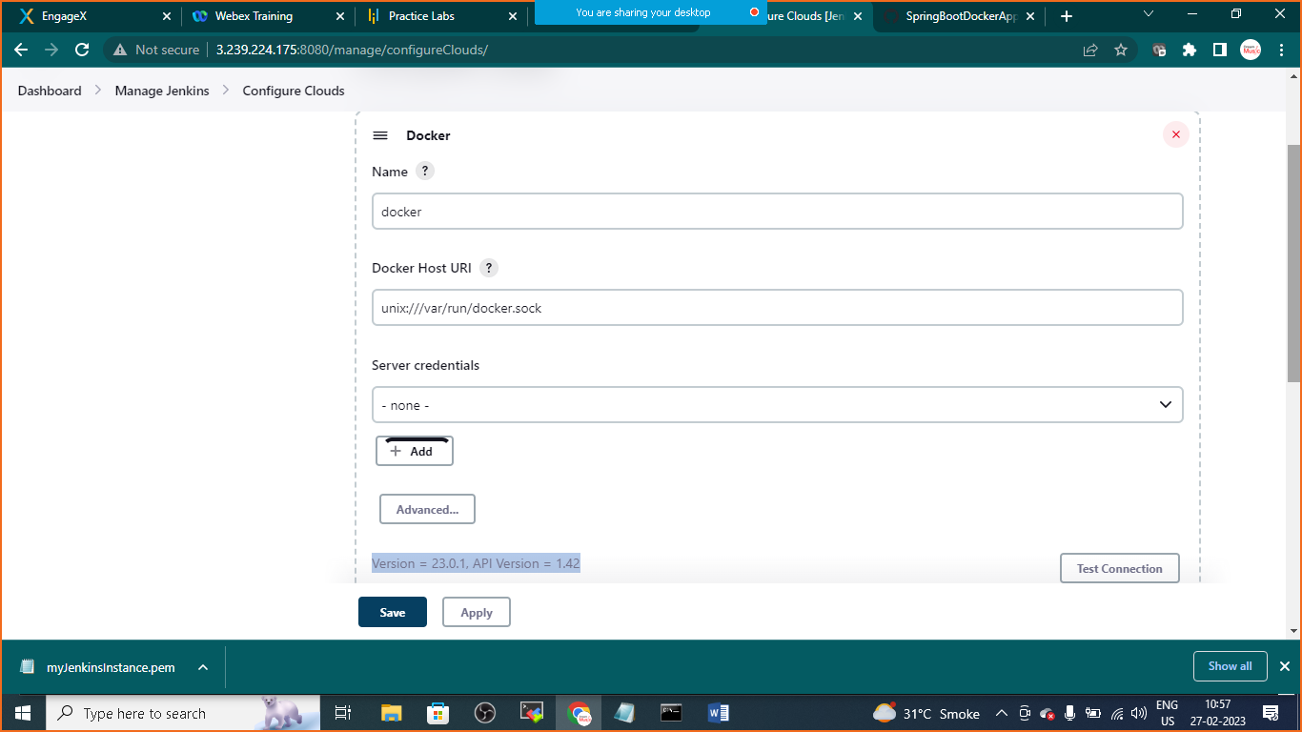

v

v

Click on apply and save

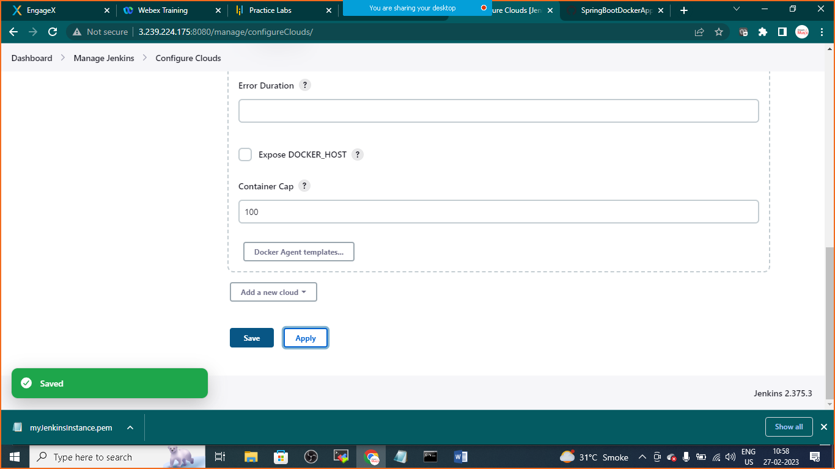

Goto>dashboard>create>new job>select freestyle project>

Give the name as Jenkins CICD Pipeline

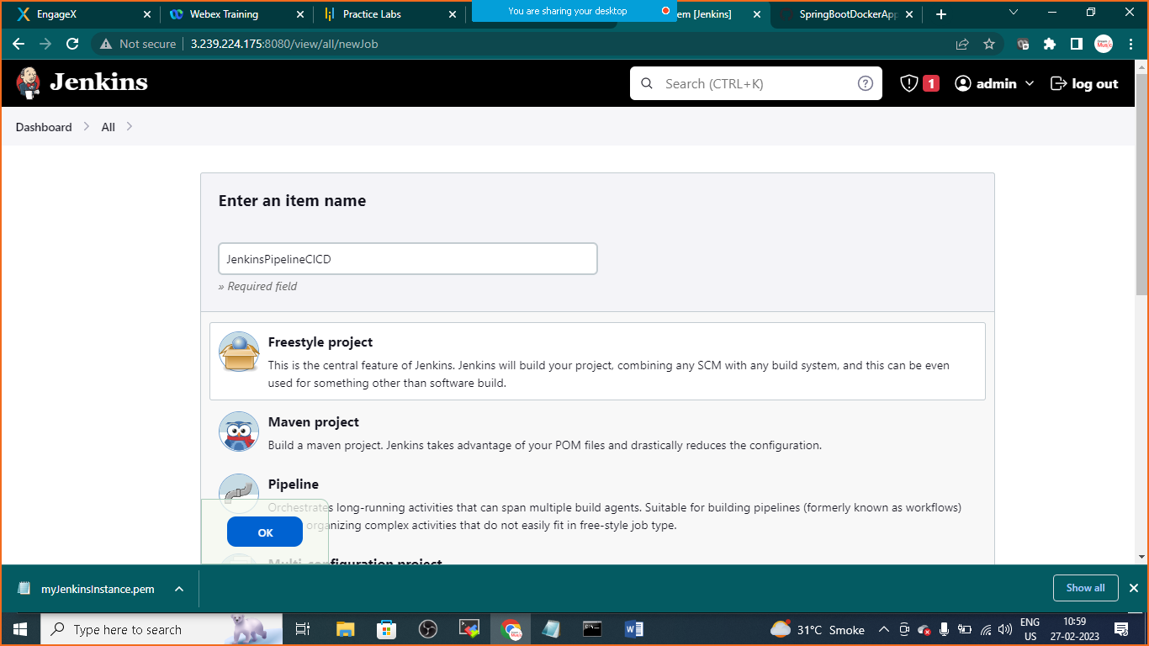

Goto >source code management

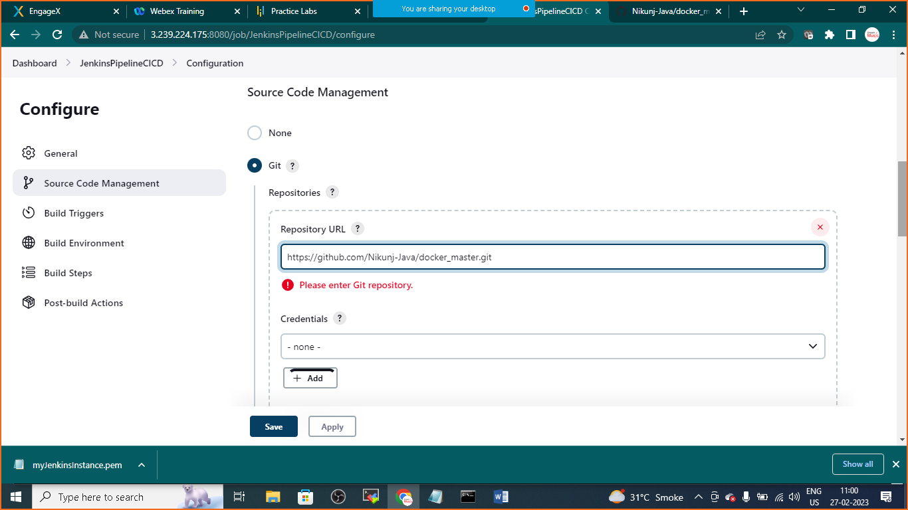

Provide GITHUB Link: <https://github.com/Nikunj-Java/docker_master.git>

Then in Build Triggers

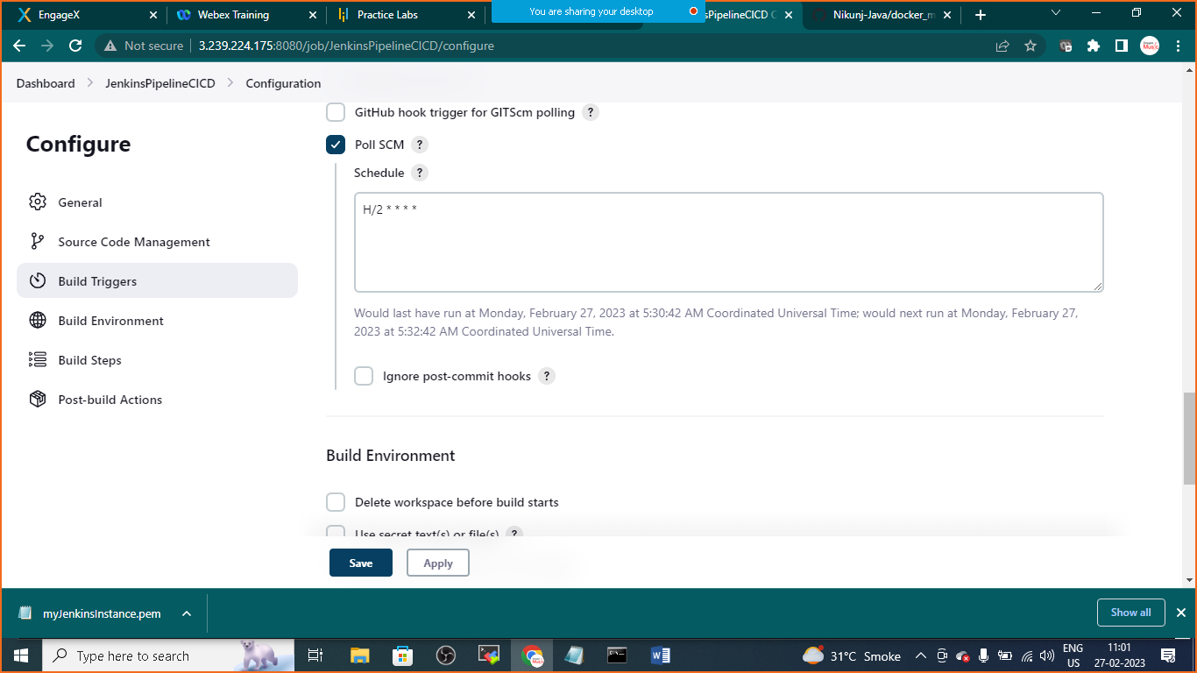

Choose poll SCM

In Schedule: H/2 * * * *

Build Environment:

Choose Build/Publish Image

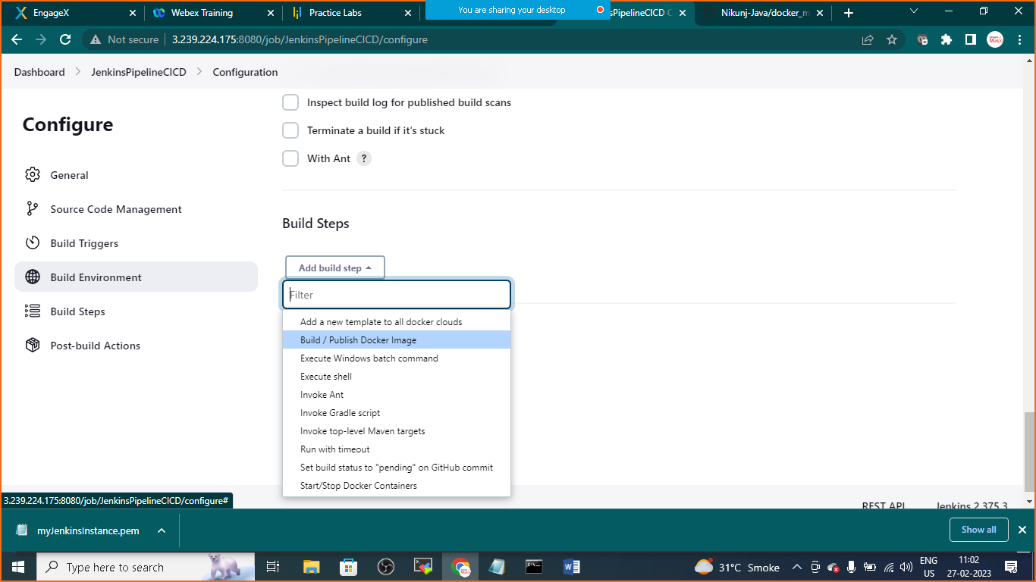

Build Steps:

Image: <yourDockerHubUsername>/<repositoryname-yoou can give any name>

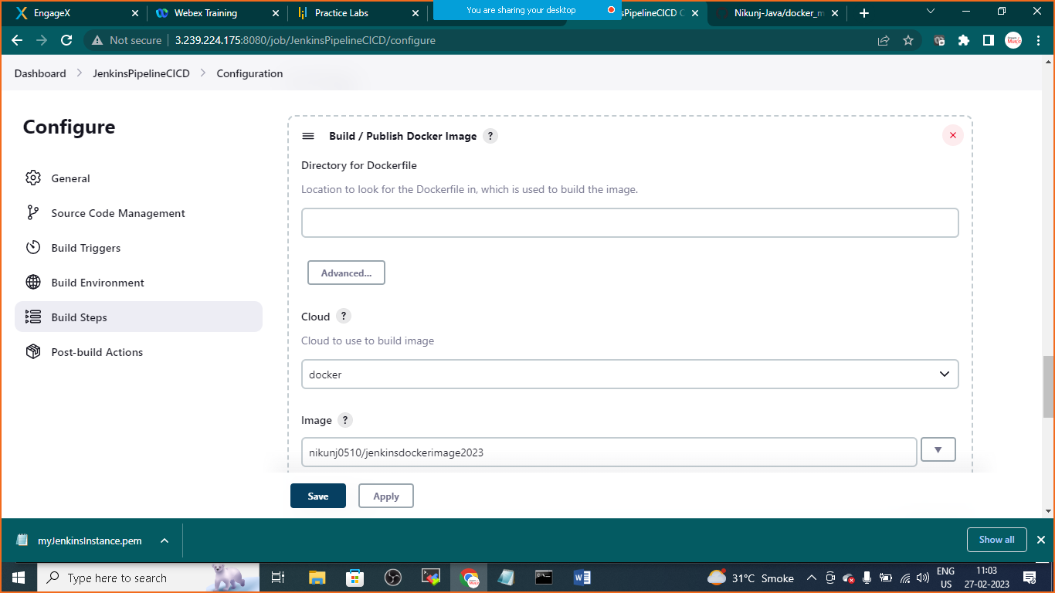

Click on push image

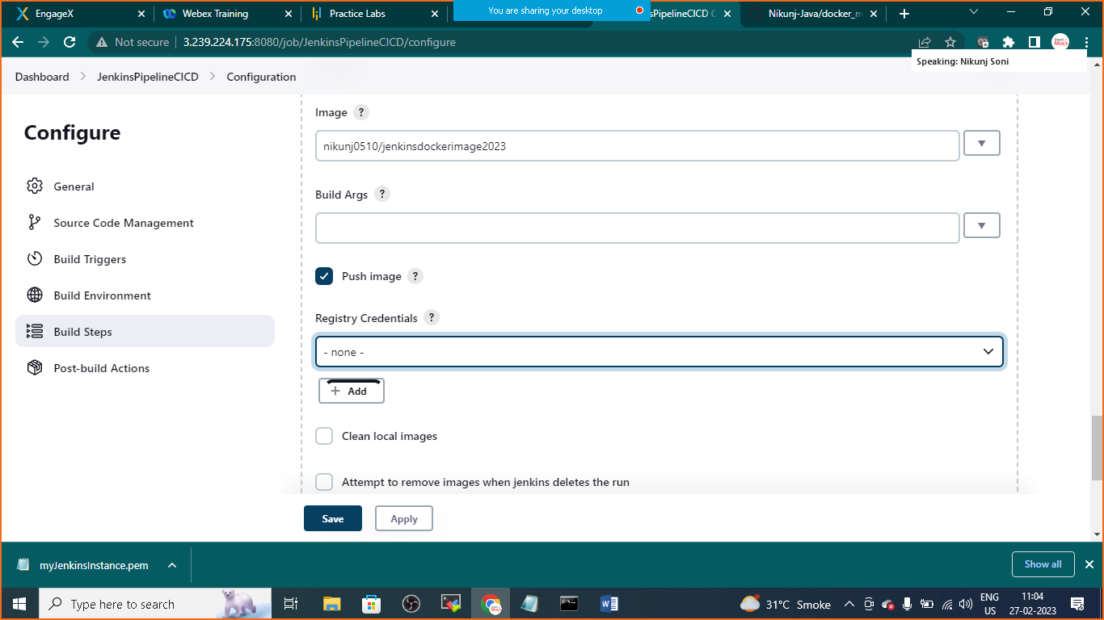

+ADD click on add icon to add your Docker Hub Login Credentials

Provide

1. Username
2. Password
3. ID

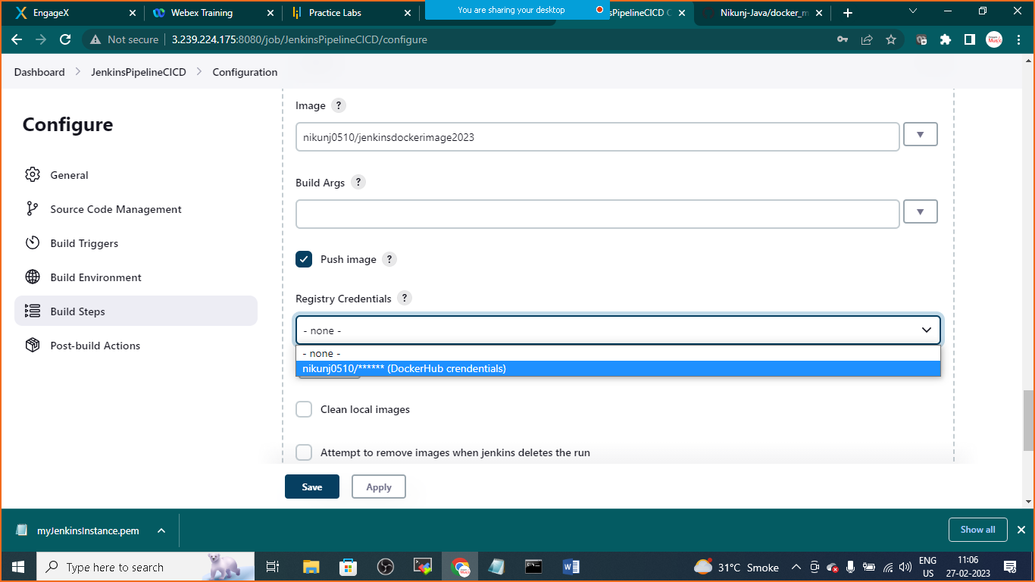

From dropdown choose your Credentials

**POST Build Actions**

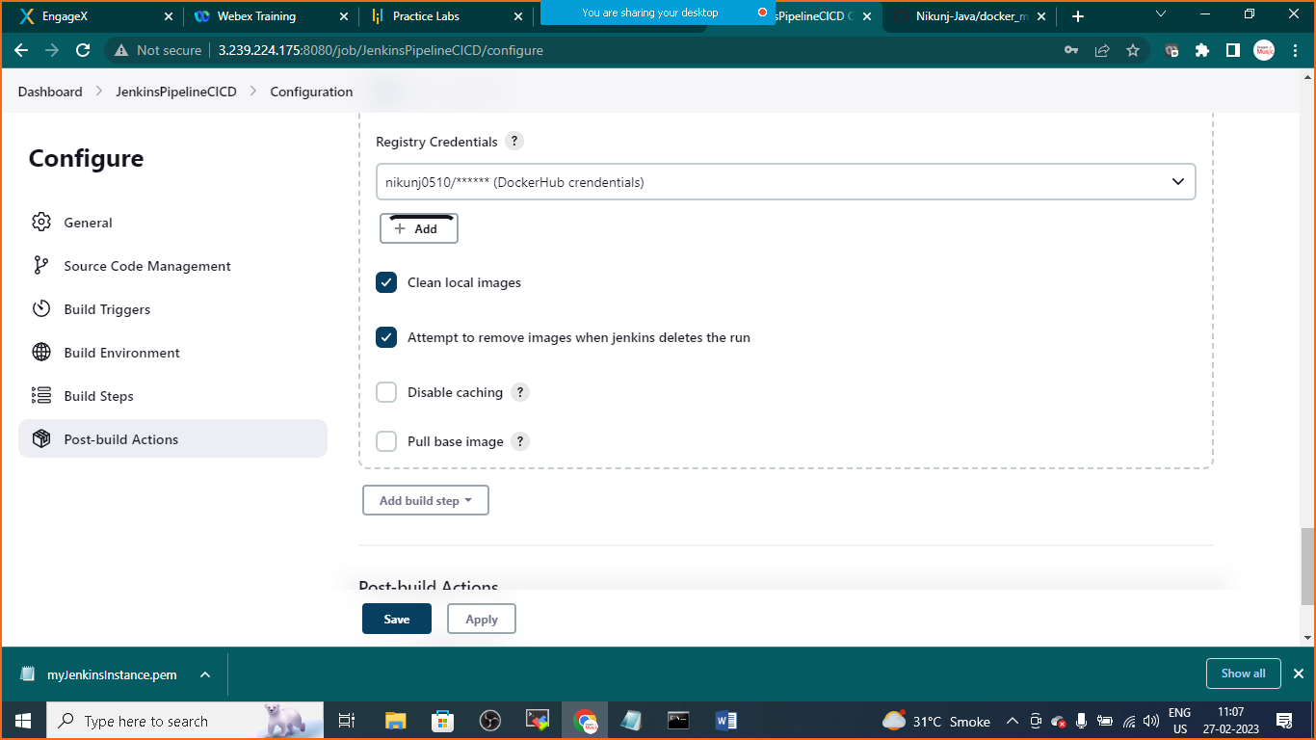

Click on Apply and Save

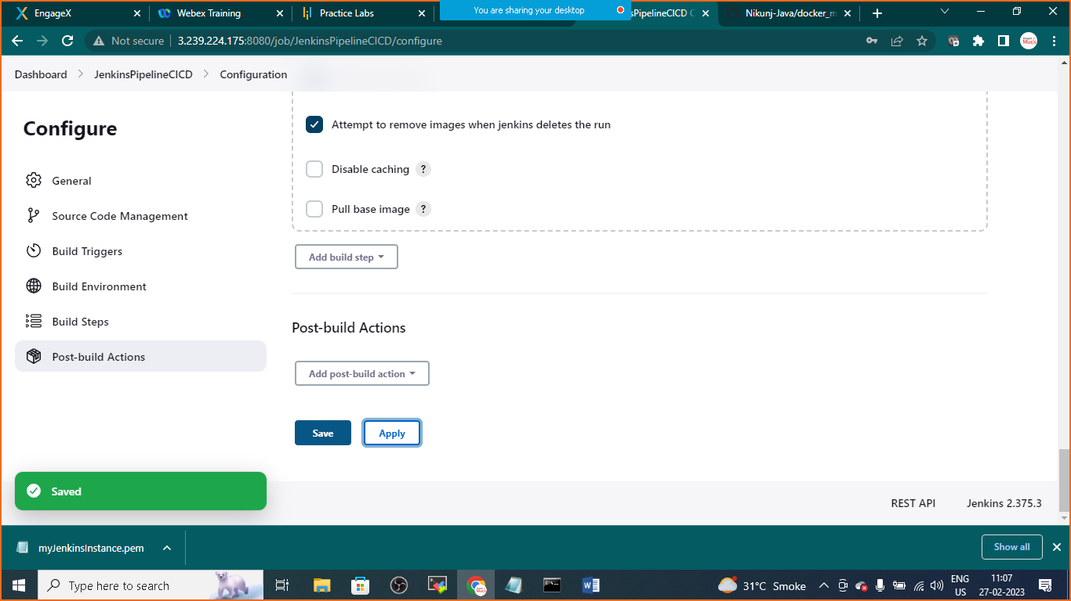

Click on build now

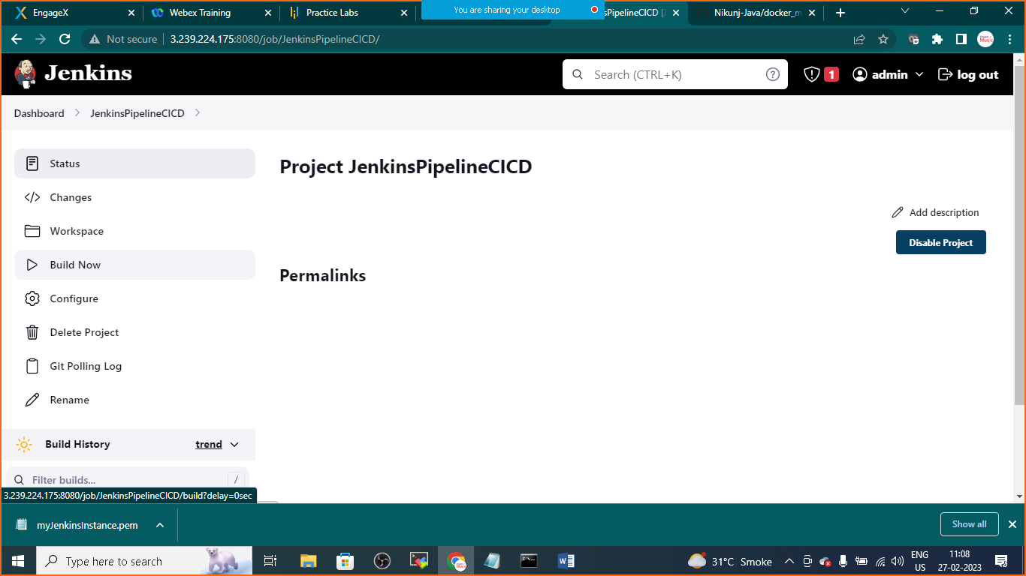

Open your docker hub account and check for the newly updated /created image

